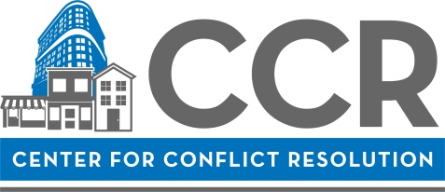

Mediator Mentorship Program (MMP) 2019 Cycle One Application

Personal Information

Name: | Click here to enter text.
Address: | Click here to enter text.
 | Click here to enter text.
Cell #: | Click here to enter text. |  | Work #: | Click here to enter text. | Other#: | Click here to enter text.
Email: | Click here to enter text.
Employer: |  | Click here to enter text.
Title: |  | Click here to enter text.

Confirm Dates
Please check the boxes next to each set of dates to confirm your availability.

Information Session (required)
☐ I have attended the MMP Information Session (1/9/19 or 1/17/19)
Date Attended: ______________________________________________________________________

Training (check all that apply)
☐ I have participated in a 40-hour mediation skills training within the last 18 months.
Date(s) and Training Organization(s): ____________________________________________________
☐ I have participated in a 40-hour mediation skills training, but longer than 18 months ago.
Date(s) and Training Organization(s): _____________________________________________________
☐ I have participated in CCR’s Essentials Training within the last 18 months.
Date: _____________________________________________________

MMP 2019 Cycle One:
☐ February 22: Orientation, 3:00pm – 5:00pm
☐ March 21: First Check-in & Agreement Writing, 1:30 p.m. to 5:00 p.m.
☐ April 23: Second Check-in & Adapted Model Training, 1:30 p.m. to 5:00 p.m.
☐ May 24: Expected Date of Certification
☐ August 22: Post Certification Check-in, 1:30 p.m. to 5: 00 p.m.

Essay
Please answer the following questions in approximately 150 words per question:

- What inspired your interest in mediation?

- Why would you like to become a volunteer for CCR?

- Please describe the unique factors you feel you would bring to CCR if certified as a volunteer mediator.

- Briefly provide an example of a conflict you have faced either personally, or as an advisor to someone else. (For example: What approaches did you use? How did you determine what was important? How did you handle the emotions involved?)

- Explain your availability to mediate in the court programs you selected. Describe your current schedule: school, employment, and other commitments. Explain what adjustments you would make in order to mediate at our priority programs (Bridgeview & Markham).

- Please indicate your method of travel to each of the selected court programs.

- If you are able to mediate in a language other than English, please describe proficiency, ability and experience using the other language(s).

Fees
Fees for the MMP are due by Feb. 22, 2019. For your convenience, you can also arrange to make installment payments by contacting Israel Putnam, Program Coordinator. Please mail checks payable to Center for Conflict Resolution and mail to 11 E. Adams Street, Ste. 500, Chicago, IL 60603. Failure to make payment or arrangements for installment payments by this deadline might affect your ability to participate.

Scholarships

If you are interested in receiving partial or full scholarship for this training program, please answer the following questions. Please note, you may be asked to provide proof of income or financial status (i.e. W2 form, pay stub, or copy of previous year’s tax return):

- Are you applying for a partial or a full scholarship? If partial, how much can you contribute toward the
cost of the training?

- Briefly describe your financial need.

- If we are unable to provide you with a full scholarship, would you be interested in applying for a partial
scholarship? If so, how much can you contribute toward the cost of the program?

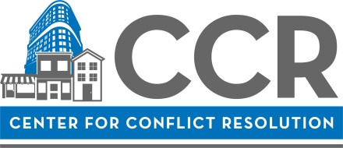

CCR MEDIATION PROGRAMS

Mediators are required to mediate twice per month, including at least once per month at one of our priority program locations: the Markham and Bridgeview Courthouses. Please indicate below all the programs and locations at which you would be available to mediate. If there are certain programs you prefer, you may indicate that as well. Use the space provided in Essay Questions 5 or 6 above.

Priority Programs in the Circuit Court of Cook County served by CCR Mediators

☐ Markham Courthouse  Location:  16501 S. Kedzie Parkway  Markham, IL 60426  Schedule:  Tuesdays Thursdays  10:00am – 1:00pm 9:00am – 12:00pm  Details:  30 minute mediations for small claims and evictions disputes. |  | ☐ Bridgeview Courthouse  Location:  10220 S. 76th Avenue  Bridgeview, IL 60455  Schedule:  Tuesdays & Wednesdays  9:15am – 12:15pm  Details:  60 minute mediations for small claims and evictions disputes.
Additional Circuit Court Districts in Cook County served by CCR Mediators

☐ Daley Center Courthouse  Location:  50 W. Washington  Chicago, IL 60612  Schedule:  Monday-Fridays  9:00am – 12:00pm  Details:  30 and 60 minute mediations for small claims disputes. | ☐ Skokie  Courthouse  Location:  5600 Old Orchard Rd.  Skokie, IL 60077  Schedule:  Mondays  1:00 – 4:00pm  Details:  60 minute mediations for small claims disputes. | ☐ Maywood Courthouse  Location:  1500 Maybrook Dr.  Maywood, IL 60153  Schedule:  Mondays  1:15 – 4:15 pm  Details:  30 and 60 minute mediations for small claims disputes. | ☐ Rolling Meadows Courthouse  Location:  2121 Euclid Ave  Rolling Meadows, IL 60008  Schedule:  Fridays  8:45 a.m. – 12:00pm  Details: 60 minute mediations for small claims disputes.

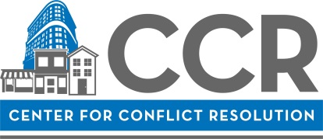

CCR COMMITMENT CONTRACT

Thank you for your interest in the MMP at the Center for Conflict Resolution (CCR). We are known for having quality volunteer mediators and takes pride in offering high quality and consistent mediation services to our clients. In order to maintain our high level of service, we ask volunteers to commit to the following (please read and initial the individual lines and sign at the bottom):

Click here to enter text. | I agree that if certified to serve as a Volunteer Mediator with CCR at the end of the Mediator Mentorship Program, I will accept the position of Volunteer Mediator with CCR.
Click here to enter text. | I agree that if I am approved to serve as a Volunteer Mediator with CCR at the end of the Mediator Mentorship Program, I will schedule to mediate for CCR at least twice a month for a period of eighteen (18) months, including once a month at one of the Priority Programs. I agree that if I do not meet this commitment and I was granted a scholarship for participation in either the 40-hour Mediation Skills Training or Mediator Mentorship Program, I will be required to compensate CCR for the difference between my fee for training and the total fee, including both the 40-hour skills training and mentorship fees.
Click here to enter text. | I agree that if approved to serve as a Volunteer Mediator with CCR at the end of the Mediator Mentorship Program, I will participate in CCR’s Peer Review process within my first 12-month period of certification.
Click here to enter text. | I agree that if approved to serve as a Volunteer Mediator with CCR, I will attend two CCR Continuing Education Programs within my first 18-month period of certification.

Click here to enter text. |  | Click here to enter text.
Signature Date
(To sign the form, type your full name here.)

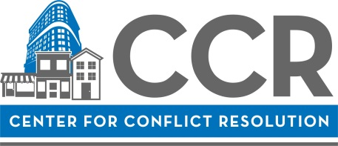

MMP Application Checklist

☐ Provide contact information
☐ Review and confirm availability for all dates for the program
☐ Answer essay questions in approximately 150 words per question
☐ Answer questions related to Scholarship Application (if applicable)
☐ Make Selections under Court Programs on Page 4
☐ Sign CCR Commitment Contract
☐ Submit resume with application

Please submit this completed application, along with your resume, to:

Israel Putnam
Programs Manager
iputnam@ccrchicago.org

Electronic submission is preferred. If you are unable to submit electronically, please mail your application materials to:

ATTN: Israel Putnam
Center for Conflict Resolution
11 E Adams Street, Ste. 500
Chicago, IL 60603

If you have any questions, please call Israel Putnam at 312-922-6464 Ext. 14

