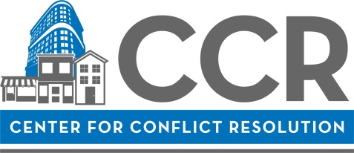

Mediator Mentorship Program (MMP) 2021 Cycle One Application

Personal Information

Name: | Click here to enter text.
Address: | Click here to enter text.
 | Click here to enter text.
Cell #: | Click here to enter text. |  | Work #: | Click here to enter text. | Other#: | Click here to enter text.
Email: | Click here to enter text.
Employer: |  | Click here to enter text.
Title: |  | Click here to enter text.

Confirm Dates
Please check the boxes next to each set of dates to confirm your availability.

Information Session (optional)
☐ I have attended the MMP Information Session (3/3/2021 or 3/4/2021)
Date Attended: ______________________________________________________________________

Previous Training (check all that apply)
☐ I have participated in a 40-hour mediation skills training within the last 24 months.
Date(s) and Training Organization(s): ____________________________________________________
☐ I have participated in a 40-hour mediation skills training, but longer than 24 months ago.
Date(s) and Training Organization(s): _____________________________________________________
☐ I have participated in CCR’s Essentials Training within the last 24 months.
Date: _____________________________________________________

MMP Training Availability
☐ I am available Wednesday afternoons between March and May for virtual class trainings.
☐ I am available weekly and with some flexibility between March and May to meet with my mentor.

Essay
Please answer the following questions in approximately 150 words per question:

- What inspired your interest in mediation?

- Why would you like to become a volunteer for CCR?

- Please describe the unique factors you feel you would bring to CCR if certified as a volunteer mediator.

- Briefly provide an example of a conflict you have faced either personally, or as an advisor to someone else. (For example: What approaches did you use? How did you determine what was important? How did you handle the emotions involved?)

- Explain your availability to mediate. Describe your current schedule: school, employment, and other commitments. Explain what adjustments, if any, you would make in order to mediate cases.

Click here to enter text.
- If you are able to mediate in a language other than English, please describe proficiency, ability and experience using the other language(s).

Fees
Fees for the MMP are due by April 9, 2021. For your convenience, you can also arrange to make installment payments by contacting Israel Putnam, Program Coordinator. Please mail checks payable to Center for Conflict Resolution and mail to 11 E. Adams Street, Ste. 500, Chicago, IL 60603. Failure to make payment or arrangements for installment payments by this deadline might affect your ability to participate.

Scholarships

If you are interested in receiving partial or full scholarship for this training program, please answer the following questions. Please note, you may be asked to provide proof of income or financial status (i.e. W2 form, pay stub, or copy of previous year’s tax return):

- Are you applying for a partial or a full scholarship? If partial, how much can you contribute toward the
cost of the training?

- Briefly describe your financial need.

- If we are unable to provide you with a full scholarship, would you be interested in applying for a partial
scholarship? If so, how much can you contribute toward the cost of the program?

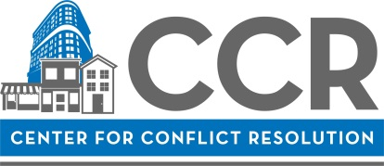

CCR COMMITMENT CONTRACT

Thank you for your interest in the MMP at the Center for Conflict Resolution (CCR). We are known for having quality volunteer mediators and takes pride in offering high quality and consistent mediation services to our clients. In order to maintain our high level of service, we ask volunteers to commit to the following (please read and initial the individual lines and sign at the bottom):

Click here to enter text. | I agree that if certified to serve as a Volunteer Mediator with CCR at the end of the Mediator Mentorship Program, I will accept the position of Volunteer Mediator with CCR.
Click here to enter text. | I agree that if I am approved to serve as a Volunteer Mediator with CCR at the end of the Mediator Mentorship Program, I will schedule to mediate for CCR at least twice a month for a period of eighteen (18) months. I agree that if I do not meet this commitment and I was granted a scholarship for participation in either the 40-hour Mediation Skills Training or Mediator Mentorship Program, I will be required to compensate CCR for the difference between my fee for training and the total fee, including both the 40-hour skills training and mentorship fees.
Click here to enter text. | I agree that if approved to serve as a Volunteer Mediator with CCR at the end of the Mediator Mentorship Program, I will participate in CCR’s Peer Review process within my first 12-month period of certification.
Click here to enter text. | I agree that if approved to serve as a Volunteer Mediator with CCR, I will attend two CCR Continuing Education Programs within my first 18-month period of certification.

Click here to enter text. |  | Click here to enter text.
Signature Date
(To sign the form, type your full name here.)

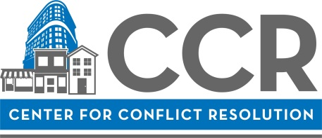

MMP Application Checklist

☐ Provide contact information
☐ Review and confirm availability for all dates for the program
☐ Answer essay questions in approximately 150 words per question
☐ Answer questions related to Scholarship Application (if applicable)
☐ Sign CCR Commitment Contract
☐ Submit resume with application

Please submit this completed application, along with your resume, to:

WE NEED AN EMAIL ADDRESS

